Mohamed Sondo CSC 336

Prof Peter Barnet Spring 2017

Homework 3.

Question 1 :

a-In order to combine sales and salesdetails table, we can Join the date field in sales to the column in salestails. The Date is field the the only one that we need to join to saledetails.

1. Our new table will have a composite primary key of stor-id, ord_num and title_id.

As foreign key we will have title-id referring to the title_id in the title table.

2 Query For Combining sales and salesdetail.

-CREATE TABLE sales_and_salesdetail_union

AS (SELECT * FROM salesdetail);

-ALTER TABLE sales_and_salesdetail_union ADD date datetime

-UPDATE sales_and_salesdetail_union INNER JOIN sales ON sales_and_salesdetail_union.stor_id = sales.stor_id and sales_and_salesdetail_union.ord_num = sales.ord_num SET sales_and_salesdetail_union.date = sales.date

Result: After these 3 query we are creating a combine table of sale and salesdetails with contains all of the date.

We I habe attached the extra credit condition for each case.

Output of Show Create table sales_and_salesdetail_union

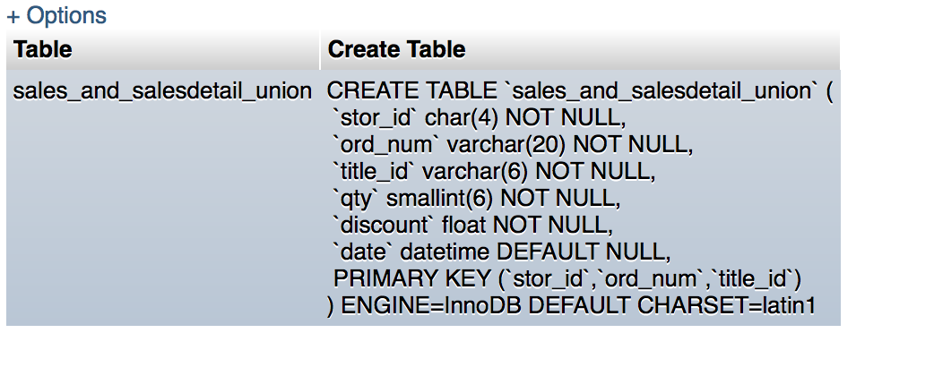

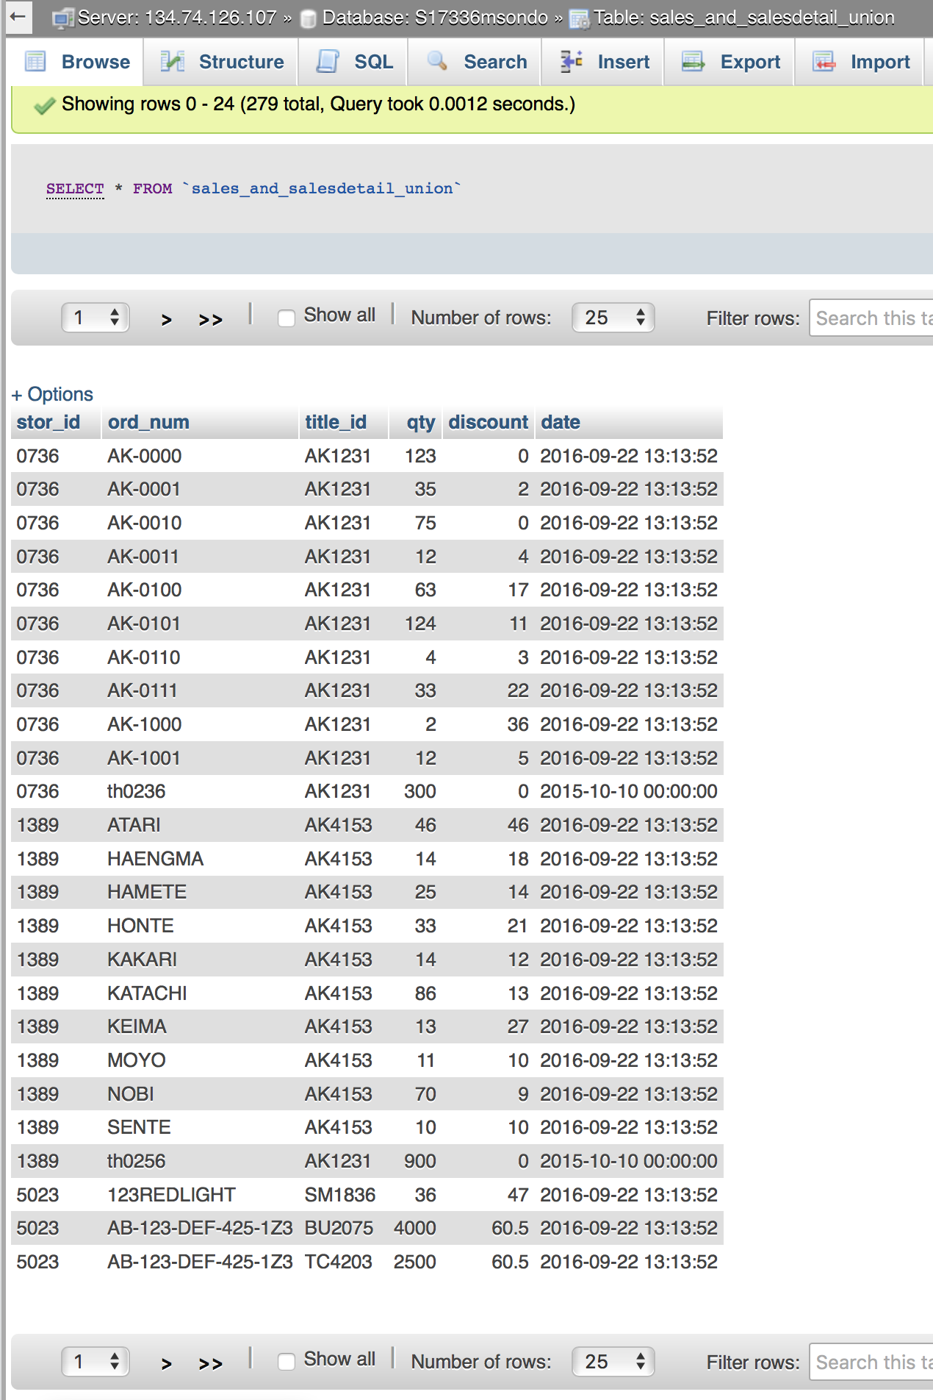

4- In order to uniquely identify our combine table, we will have as primary key stor_id, ord_num and title_id.

5-whitout (stor-id, ord-num and title_id) we can not determine quantiy, discount and date, therefore they will be the functional dependency.

6-stor_id and ord_num together determine date. Both are not enough to make a key to uniquely identity our newly created table. Both(stor_id and ord_num will be consider as an incomplete key)

7- Question 6 tell us our table is not in BCNF because we have non-trival functional dependency.  A table is in BCNF if and only if there are no non-trivial functional dependencies of attributes on anything other than a superset of a candidate key. It failed 3NF since all column reference in referenced data that are not dependent on the primary key cannot be removed. The foreign is not the only one that we should use to reference another table. Our table is in 2NF and 1NF since  every non-prime attribute of the relation is dependent on the whole of every candidate key.

b-We do not need to combine sales and salesdetails to satisfy BCNF. We know that if a relation schema is in BCNF then all redundancy based on functional dependency has been removed, although other types of redundancy may still exist. Sales table has as primary key(stor_id and ord_num) and combining both of as a superkey allow us to determine date.

Salesdetails table has primary key( stor_id, ord_num and title_id) as left side of our FD and allow us to get Quantity and discount, there are in order to generate a super of our new table we have to include title_id which come from salesdetail to stor_id and ord_num to generate a composite key that will serve to uniquely identify the table. Stor_id and ord_num alone cannot be use to identify the attribute on the right side causing a violation of BCNF. This is the reason why the table was separated into to different table.

2-Titleauthors and publication databases.

a-Combination of titleauthor and titles.

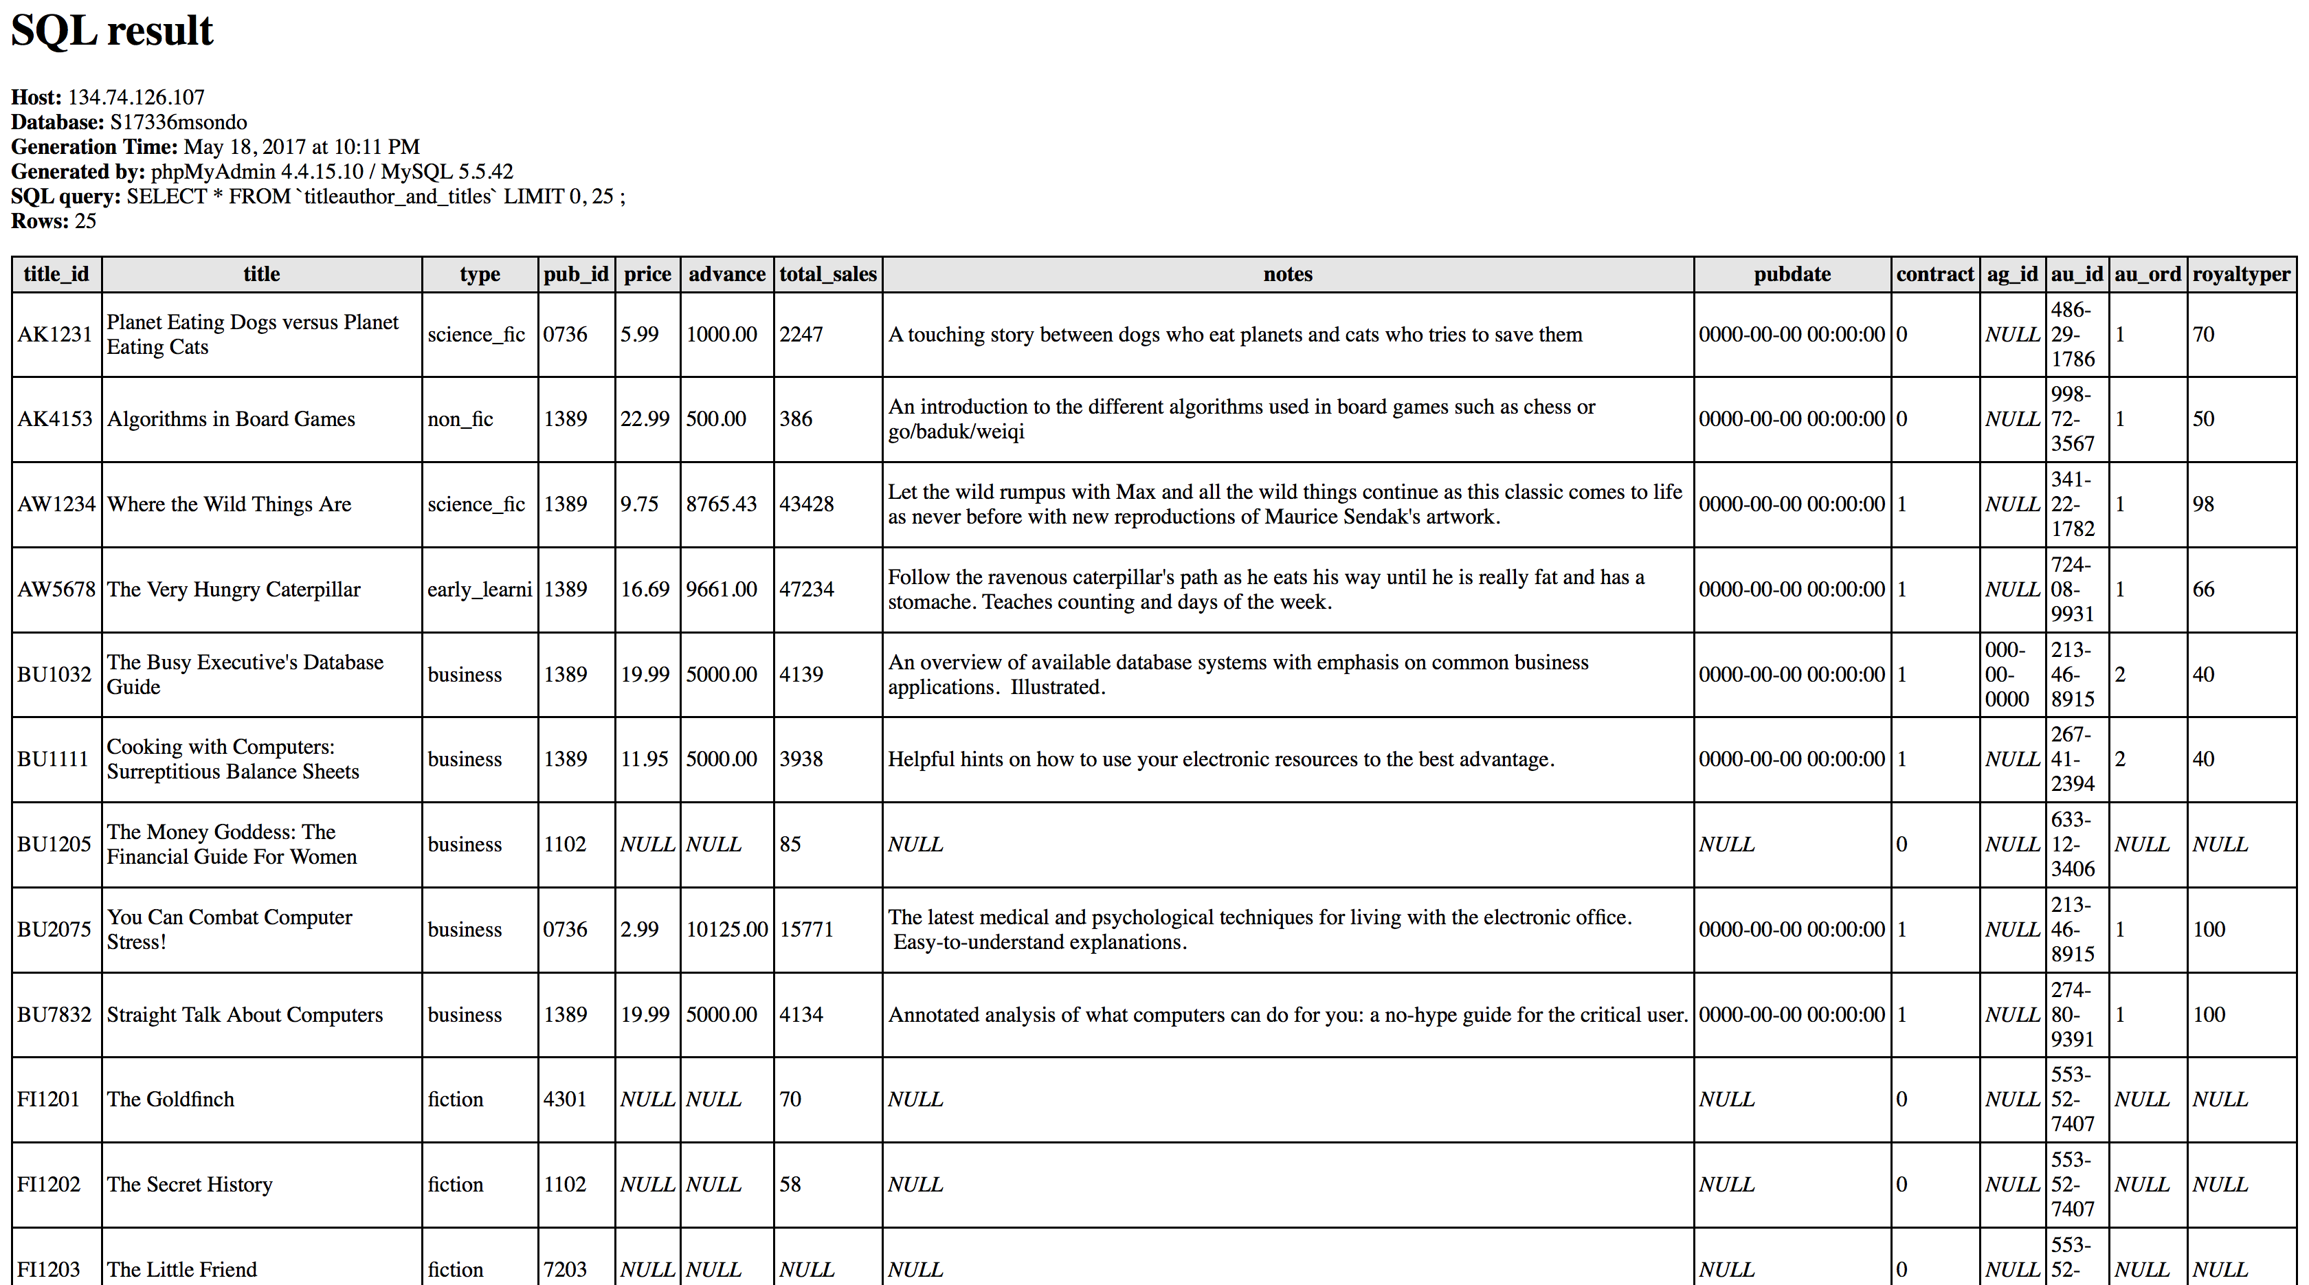

1. Schema and query used.

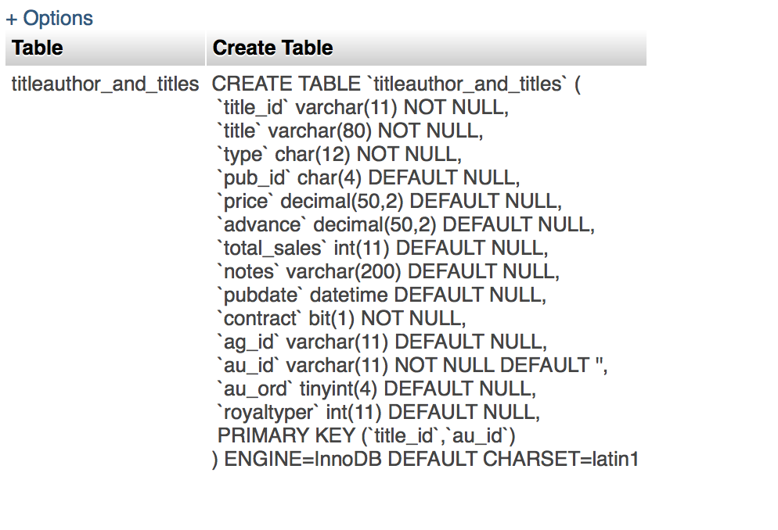

CREATE TABLE titleauthor_and_titles

AS (SELECT * FROM titles);

ALTER TABLE titleauthor_and_titles ADD au_id varchar(11);

ALTER TABLE titleauthor_and_titles ADD au_ord tinyint(4);

ALTER TABLE titleauthor_and_titles ADD royaltyper int(11);

UPDATE titleauthor_and_titles INNER JOIN titleauthor ON titleauthor_and_titles.title_id = titleauthor.title_id SET titleauthor_and_titles.au_id = titleauthor.au_id, titleauthor_and_titles.au_ord=titleauthor.au_ord,titleauthor_and_titles.royaltyper=titleauthor.royaltyper;

2-

3- [ALTER](http://www-cs.ccny.cuny.edu/~cs336/phpMyAdmin/url.php?url=http://dev.mysql.com/doc/refman/5.5/en/alter-table.html) [TABLE](http://www-cs.ccny.cuny.edu/~cs336/phpMyAdmin/url.php?url=http://dev.mysql.com/doc/refman/5.5/en/alter-table.html) `titleauthor_and_titles` ADD PRIMARY KEY( `title_id`, `au_id`);

title_id and au_id will have to be unified together in order to generate a primary key for the newly create table after combining titleauthors and title. Originally titleauthor has (au_id, title_id) as it primary key and titles has title_id as it primary key. We can see that both table have title_id in common and in order to uniquely identify the new table, we have to bring piece of each tables to make possible.

4-Yes there are FDs whose left side is the Pk.titleauthors has primary key(au_id and title_id) and au_ord and royaltyper depend on them in order to exist. Without these 2 primary key it will be hard dertermine au_ord and royaltper.

.

5.Yes there are FDs whose left side is not the PK title_id by itself is not the whole key. All of the other field in titles depend title_id, but not the other field in titleauthors.

6- This is in the 2NF because to be in Second Normal Form Table has to satisfy following criteria.

*Table should be in First Normal Form.*

*There should be no partial dependency between non-key attributes and composite key. A partial dependency occurs when a non-key attribute is dependent on only a part of the (composite) key.*

*There should be no subset of data that comes with multiple rows in a table. Place that data into different table.*

*Define relationships among the new tables and the base table using foreign*

Our  table Does not satisfy the 3NF non-key column should depend on other non-key column or has a transitive functional dependency.

In our case au_ord and royaltyper is fully functionaly depends on au_id on titleauthor table.

b- the reason why they are separated in 3 different tables is because of the FDs of au_or and royaltyper on au_id. By decomposing to 3 table we create A primary key for title_id for title, au_id for authors and define a Fk relation of authors with titleauthors table using au_id column. We set title_id and au_id combination as primary key in titleauthors.

3-

1. It will not be a great idea to choose trains as entity and stations as attribute because station name and Station symbol full depend on the Station. Without a station idea, it will be hard identifying each station and connecting train to station will have some redundancy.

Since there is exist an FDs I is better to make Stations as a separate table.

b. the Attribute will be stop_at since we know that each train as a specific stop at time and stops-at does not FDs. We might consider Free seat since it also being to a train in specific segment.

c-

d-We can represent

the cases where a train does not stop at a station by setting on the stops_at table, the train_id to be Null. Indicating that train with the corresponding id, may pass through the station but do not stop there.

E- f arrival time and Departure can be represented using time_in and time_out corresponding to the train_id with a specific id through the right station. These attributes should all the use to create a composite key for the new tables

g- Our newly created table satisfy BCNF since *Every determinant must be a candidate key train_id and time_in and time_out station_id and stop-at are necessary in order uniquely identify the newly created table.*